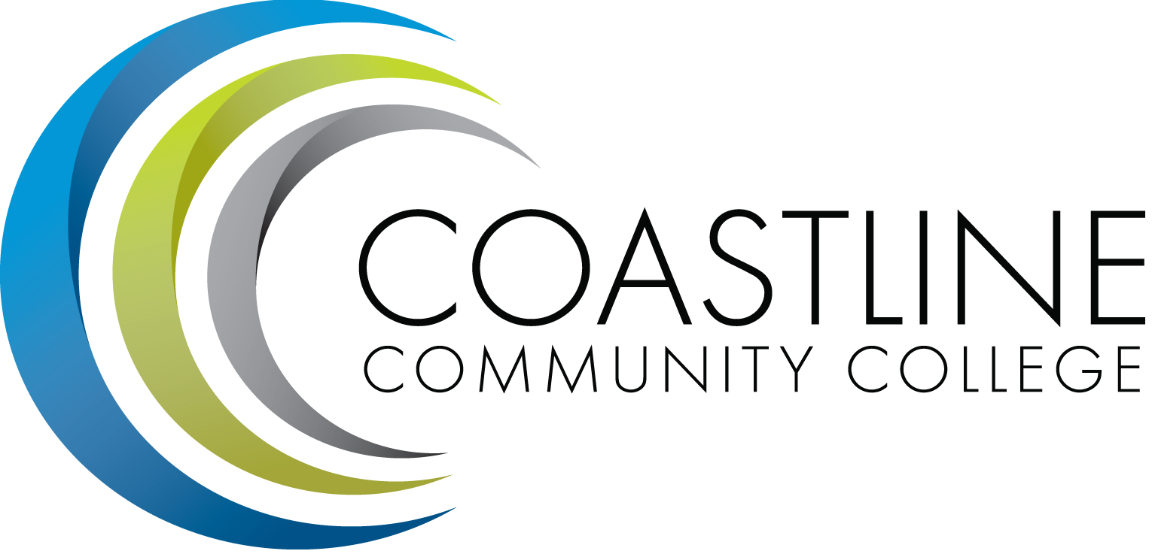

ACADEMIC SENATE
November 7, 2017 12:30 p.m. - 2:30 p.m.
College Center--Fourth Floor Conference Room
Draft AGENDA
College Mission Statement: Coastline Community College steadfastly focuses on providing access and supporting student success and achievement. Inspired by an innovative and student-centered mindset, Coastline delivers flexible courses and services that cultivate and guide diverse student populations across the globe to complete pathways leading to the attainment of associate degrees, certificates, career readiness, and transfer to four-year colleges/universities.

12:30 p.m. 1. CALL TO ORDER: President Stephen Barnes
1.1 Pledge of Allegiance
1.2 Roll Call
1.3 Welcome
1.4 Adopt Agenda
1.5 Approval of Minutes –October 17, 2017 **
1.6 Consent Calendar
1.6.1 Integrated Plan-Dr. Julie Mendez**
1.6.2 OER sub-committee

1.7 Public Comment and Statement: Members of the public can address the Academic Senators on any item that has been described in this notice, before or during consideration of the item. Persons wishing to make comments are allowed three minutes.

2. SPECIAL PRESENTATION
2.1 Luminis/MyCCC and Single Sign-On-Rupa Suran
2.2 Internal Audit Hotline-Fahad S. Kazi/Rachel Snell
2.3 Proctorio-Stacey Smith
2.4 Study Abroad-Tanya Murray/Eric Leffler

3. DISCUSSION AND ACTION ITEMS
3.1 RSI Plan-Dan Johnson**
3.2 Prioritization Results-Stephen Barnes**
3.3 Integrated Planning Guide-Redline-Ann Holliday**
3.4 OER Budget-Scott Davis*

4. DISCUSSION ITEMS
4.1 District Faculty Equivalency Policy/Procedures-Ann Holliday**
4.2 SLO Handbook/PSLO-Joshua Levenshus/Dr. Aeron Zentner*
4.3 Guided Pathways Self-Assessment-Dr. Aeron Zentner**
4.4 Common Assessment Initiative Termination

5. COLLEGE COMMITTEE REPORTS
5.1 PIEAC-Stephen Barnes
5.2 Budget-Rick Lockwood
5.3 Facilities-Michael Warner
5.4 Technology-Cheryl Chapman
5.5 Professional Development & Leadership-Lisa Lee
5.6 Student Success-Ann Holliday
5.7 Curriculum-Dan Johnson
5.8 Accreditation-Danny Pittaway

6. SENATE SUBCOMMITTEE REPORTS
6.1 Academic Rank-Michael Warner
6.2 Academic Standards-Ann Holliday
6.3 Budget-Ann Holliday
6.4 Communications-David Lee
6.5 Elections-Margaret Lovig
6.6 Faculty Recognition-Ann Holliday
6.7 FSC-Rick Lockwood, Cheryl Chapman
6.8 Policy and Procedures-Deborah Henry
6.9 Social-David Lee

7. ANNOUNCEMENTS: (1-minute limit – please sign list to speak)

2:30 p.m. 8. ADJOURNMENT

*Hand-outs available at meeting.
**Copies have been sent to Senators. Others who would like a copy should contact the Senate office at academicsenate@coastline.edu.
Refreshments
Jeanne Oelstrom, Scott Davis
INFORMATIONAL HANDOUTS
- Draft minutes October 17, 2017
- CCC Guided Pathways Self-Assessment Tool
- CCC Integrated Planning Guide Draft with changes 2017-18
- Integrated Plan 10-30-17
- AP 7902 Faculty Service Areas Min Qualifications & Equivalency with edits
- Faculty Rating Sheet to Prioritize Additional FT Faculty & Counselors 2017-18
- Administrator Rating Sheet to Prioritize Additional FT Faculty & Counselors 2017-18
- Faculty & Administrators Combined Rating Sheet to Prioritize Additional FT Faculty & Counselors11-07-17
- Plenary Report 2017 Fall M. Fry
- ASCCC Fall 2017 Plenary Session M. Lovig
- Coastline Hayward Nomination Form
- RSI Taskforce Recommendations

Contact the Senate Office ~~ We welcome your input!
Stephen Barnes (714) 241-6156 ~~ Email: academicsenate@coastline.edu
Academic Senate Website: http://www.coastline.edu/academicsenate/
Zoom Link: https://zoom.us/j/619853943

NOTES AND NEWS
Stephen Barnes, Academic Senate President
November 7, 2017

- Veterans Day Holiday: Friday, November 10, 2017; All Coastline Campuses are closed.

- Thanksgiving Holiday: Thursday, November 23 and Friday, November 24, 2017; All Coastline Campuses are closed.

